Energetic Duck

by Jonathan Li

Energetic Duck is a game where a person controls a tank and shoot ducks. It is based on a game called Diep.io, a simple third person tank game(though they aren’t really tanks XD). The objective is to shoot the ducks and try not to let the ducks touch you. Ducks up and down movement is a little random to make them harder to hit. Chicken nuggets will spawn every once in a while like powerups.

The user will have the ability to set how many ducks there are from 2 to 30. They can also turn penetration on (whether a bullet can kill and go through the duck). They can also turn on “shrek mode”, which turns the duck images into shrek images. (Just because this is funny, also shrek is not considered human).

The game is set in a 800 x 800 field. However the user can only move in a 400 x 400 field in the middle while ducks can move anywhere on the field. However, ducks can not spawn right on you, it spawns a little further away. This is to prevent the user being able to sit on the boundary and just shoot the ducks that are getting close. Chicken nuggets (powerup) spawn in the 400 x400 square. If the user tries moving out of the boundary, the character will be just at the wall, the character/player does not receive any punishment.

The user can use wasd key to move up, down, left and right, and they can use left click to shoot. Everytime a duck is shot, it moves.

Left click just makes the user shoot in the direction of the mouse click. There are no bullet limitation for this. Left click bullet is red. If penetration is on, it is possible for one bullet to hunt multiple ducks, as the bullet can go through a duck. If penetration is off, after the bullet hits a duck, the duck disappears, so each bullet can only hunt down one duck.

Right click shoots 12 bullets like a circle around the user. These bullets are blue. The user can only use this 5 times per game, this is to prevent this ability from being spammed. This ability will ALWAYS penetrate/go through a duck/ducks, even if penetration is set to off. As the intended purpose of this ability to be able to get out of situation where you are surrounded. The user will be able to see how many right click bullets they have left at all time.

Shift +(w/a/s/d) allows the user to go three times as fast the normal movements. I call it boost. You have 10 boosts in a game. If the user reaches the boundary and still tries to boost moving against the boundary, the boost count will keep decreasing until he stops/run out of boost. This is to prevent the user from spamming it too easily. Also if the user tries boosting two direction at the same time, it will count as TWO boosts. The boost does NOT work if the user tries to press w/a/s/d first, and then press shift. It only works if shift is pressed first. The user will be able to see how many boosts they have left at all time.

Pressing t makes the user’s ball show the word “t-bag”, pressing it again deletes it.

Touching the ducks ends the game and puts the game to the intro screen again.

There will be a timer for how long the user survives and the game will also show how many ducks the user hunted in that one game. (It does not record the ducks hunted in the previous games).

Ducks spawn at the top left corner from the start. However, when they are hit, they respawn randomly on the map. The only place they don’t spawn is right on the user’s character or very near it.

Chicken nuggets spawn anywhere inside the 400x400 (the user’s moving range). The user can eat the chicken nugget by going on top of it. -If one eats the chicken nugget, instead of left clicking, the user only has to move the mouse to shoot. (If you don’t move the mouse it won’t shoot). After eating the nugget, the user will be able to do that for 3 seconds. Chicken nuggets spawn every 15 seconds, the first nugget spawns at 10 seconds, then 25, then 40, and so on. Chicken nugget will disappear after 10 seconds of spawning.

Player opens the program and starts the game by pressing F5 or run module.

Intro screen buttons:

Play: Starts the game upon clicking it.

Instruction: The game tells how to play the game, click back and it will go back to the intro screen. It resets all the settings to default.

Amount of ducks slider: Slide it left and right to decrease/increase the amount of ducks, the default is 3.

Penetration checkbox: Determine whether a bullet will go through a duck after hitting it. Default is on. Turns/ on/off upon clicking.

Shrek mode checkbox: Determine the image of the duck. Default is off (just normal ducks). Turns/on/off upon clicking.

Looks:

Intro screen:

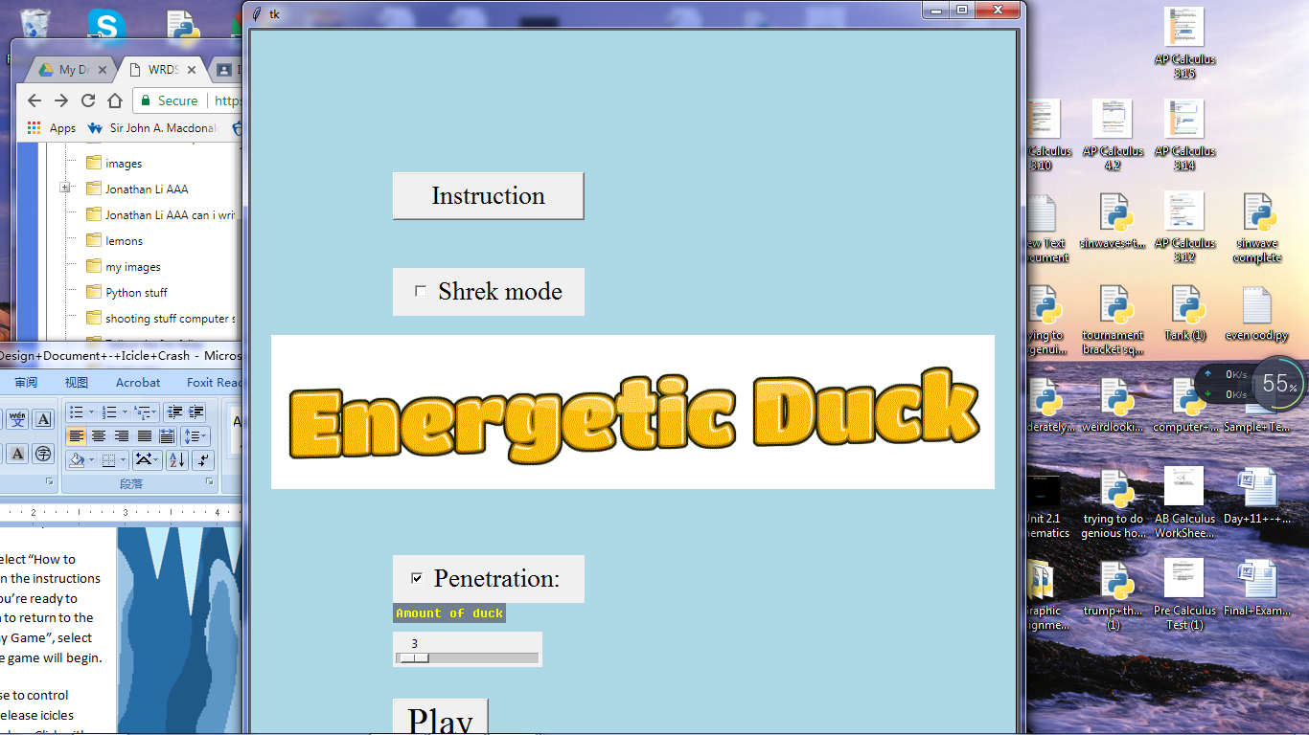

Inside the game

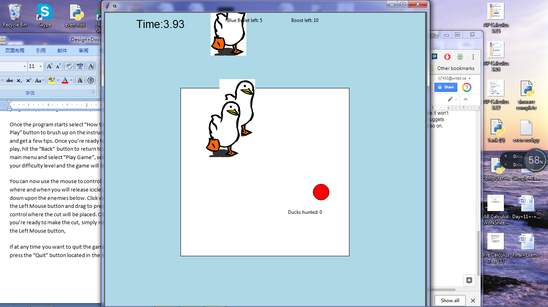

Shrek Mode:

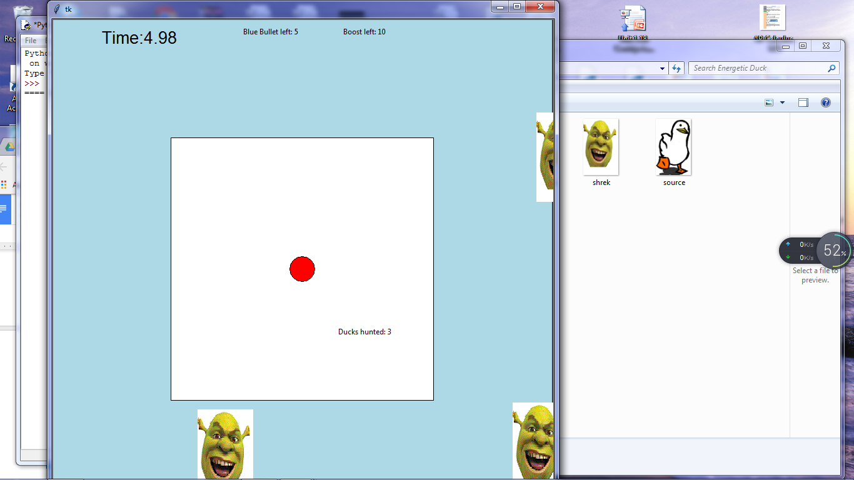

End Game Message:

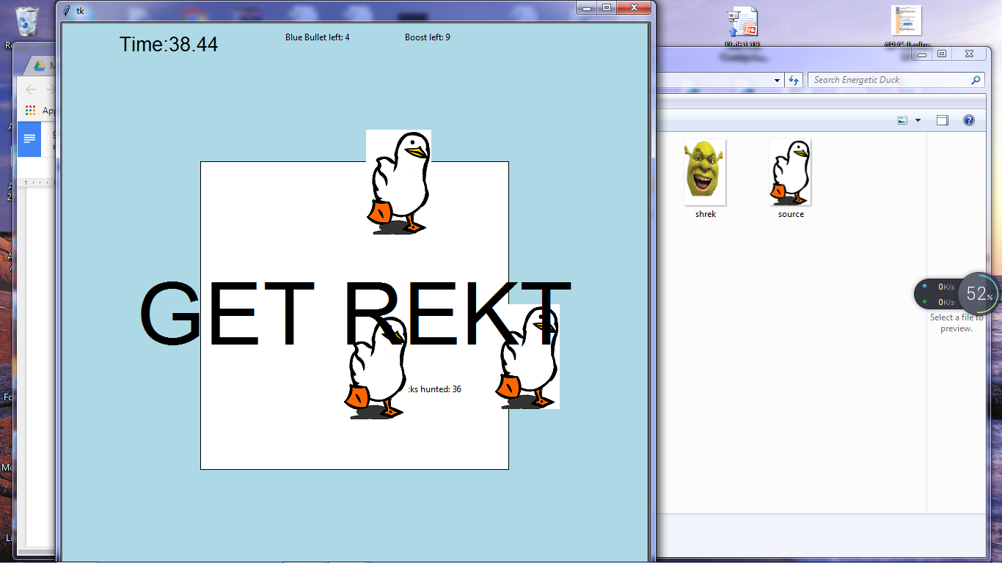

Chicken nugget:

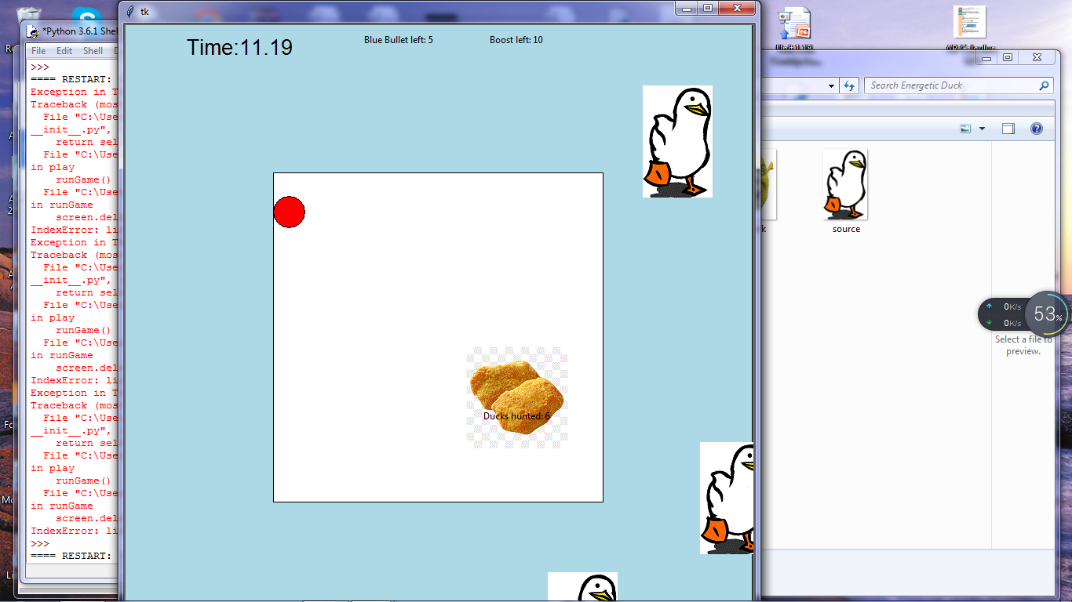

Instruction screen

